UNIVERSITY OF IBADAN
DEPARTMENT OF COMPUTER SCIENCE
2022/2023 FIRST SEMESTER EXAMINATIONS
CSC 582: INTRODUCTION TO BIOINFORMATICS
INSTRUCTION: ANSWER QUESTION 1 AND ANY TWO QUESTIONS. TIME: 2 HOURS

1a. Considering the alignment criteria shown below:
s(a, a) = + 8, s(a, b) = - 3, α = - 13, β = - 7
Utilizing the 3 gap penalty functions, calculate the alignment scores for the sequence alignment below.

T | T | A | G | - | C | T | G | - | A | C | A | T | G | A | C
T | - | - | G | C | C | T | A | C | A | T | G | T | - | - | -

10Marks
1b. In Linux file system, differentiate between the following:
- Home and Working directory 2marks
- Absolute and Relative path 2marks
- Describe 4 commands used to manipulate directory in Linux 4 Marks
- Describe any 4 wildcards in Linux 4 Marks

1c. As a bioinformatics expert, knowledge of key basic concept of molecular biology is
necessary in order to have adequate domain information to define the various problems to be solved
computationally. Using an illustrative diagram describe the centra dogma of molecular biology. 8 Marks

2a. Alignment refers to sequence comparison to find similarity level between query sequence and
different database sequences. List 4 reasons why you may want to align sequences. 4 Marks
2b. List 6 command line key combinations in Linux you are familiar with, stating their functions. 6 Marks
2c. List 5 types of modules in the BLAST Program 5 Marks

3a. Find the best alignment of these two sequences using the distance scoring system giving -2 as a gap
penalty, -3 as a mismatch penalty, and 2 as the score for a match. 10 Marks
ACATTCA
ACATCA
3b. Pubmed is the most popular choice for biomedical researchers, List 5 justifications why Pubmed is
mostly taken into account when looking for biomedical literature. 5 Marks

4a. Apply the Dot matrix approach to the sequence alignment of AGCTAGGA and GACTAGGC 6 Marks
4b. Over the years, bioinformatics tools have been used in 3 critical areas of genomic and molecular
biological research, enumerate these areas and its relevance to research. 9 Marks

5a. List 7 standard bioinformatics tools you are familiar with and their functions 7 Marks.
5b. Discuss 4 ways that computational prediction is used in bioinformatics. 8 Marks

MARKING SCHEME CSC 582

1a. There are 3 methods
- Linear gap method : here the value of the gap changes in each combination
- Constant gap method: the gap is taken only once
- Affine gap method: Substitute the values of gap, mismatch and the matches and add up

1b. In Linux file system, differentiate between the following:
- Home and Working directory 2marks
Answer
- When you first log in on a UNIX system, the working directory is your home directory.
- While working you will be associated to one directory called the working directory or the current directory.

- Absolute and Relative path 2marks
Answer
• An absolute path in the file system hierarchy for a given file or folder describes the parents all the way up to the root
• A relative path describes the path to the file starting from the current working directory
- Describe 4 commands used to manipulate directory in Linux 4marks
Answer
- mkdir: make directory: creates a new directory
- rmdir: removes a directory
- pwd: displays the absolute path of the current working directory
- cd: change directory: allows moving from one directory to another
- ls: lists a directory content

- Describe any 4 wildcards in Linux 4marks
Answer
- * Matches any characters
- ? Matches any single character
- [!characters] Matches any character that is not a member of the set characters
- [characters] Matches any character that is a member of the set characters.

1c. As a bioinformatics expert, knowledge of key basic concept of molecular biology is necessary in order to have adequate domain information to define the various problems to be solved computationally. Using an illustrative diagram describe the centra dogma of molecular biology.
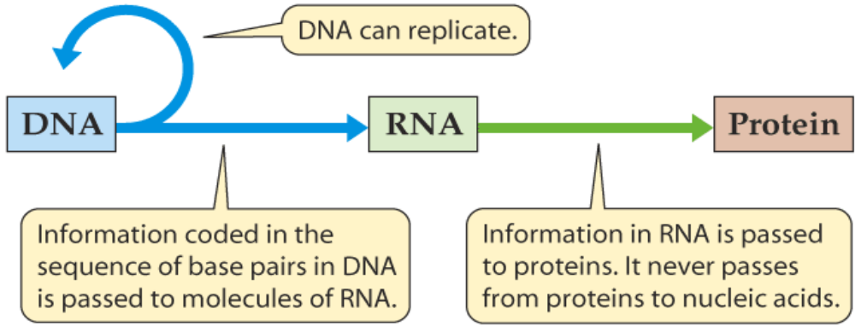
Translation
Replication
Transcription

2a. Alignment refers to sequence comparison to find similarity level between query sequence and different database sequences. List 4 reasons why you may want to align sequences.
4marks
Answer
  - To observe patterns of conservation (or variability).
  - To find the common motifs present in both sequences.
  - To assess whether it is likely that two sequences evolved from the same sequence.
  - To find out which sequences from the database are similar to the sequence at hand.

2b. List 6 command line key combinations in Linux you are familiar with, stating their functions. 6 Marks
- Ctrl+A: remove the cursor to the beginning of the command line
- Ctrl+C: end a running program and return to the prompt
- Ctrl+D: logout from the current shell session: equivalent to exit
- Tab: autocomplete a file name
- Tab Tab: displays command completion possiblities
- Ctrl+L: clear the terminal

2c. List 5 types of modules in the BLAST Program 5 Marks
  - The BLASTP program compares an amino acid query sequence against a protein sequence database.
  - The BLASTN program is used to compare a nucleotide query sequence against a nucleotide sequence database.
  - The BLASTX program translates a DNA sequence into six protein sequences using all six possible reading frames, and then compares each of these proteins to a protein database.
  - The TBLASTN program translates every DNA sequence in a database into six potential proteins, and then to compare your protein query against each of those translated proteins.
  - The TBLASTX program is the most computationally intensive BLAST algorithm. It translates DNA from both a query and a database into six potential proteins, then performs 36 protein-protein database searches.

3a. Find the best alignment of these two sequences using the distance scoring system giving -2 as a gap
penalty, -3 as a mismatch penalty, and 2 as the score for a match. 10 Marks
ACATTCA
ACATCA
For the distance Scoring system, the best alignment is the alignment with the lowest score, plug in the values of the match, mismatch and gap after alignment and add up.

3b. Pubmed is the most popular choice for biomedical researchers, List 5 justifications why Pubmed is
mostly taken into account when looking for biomedical literature. 5 Marks
i Comprehensive, current up-to-date information
ii Literature from credible sources
iii Controlled vocabulary for indexing and searching
iv Abstract and/or full text often provided
v Can filter search results to narrow query

4a. Apply the Dot matrix approach to the sequence alignment of AGCTAGGA and GACTAGGC 6 Marks

A G C T A G G A
G
A
C *
T *
A *
G *
G *
C
The hint is to pair the two sequences using row and column and then link all the matches

4b. Over the years, bioinformatics tools have been used in 3 critical areas of genomic and molecular
biological research, enumerate these areas and its relevance to research. 9 Marks

  - Sequence Analysis: It includes sequence alignment, sequence database searching, motif and pattern discovery, gene and promoter finding, reconstruction of evolutionary relationships, and genome assembly and comparison.
  - Structural Analysis: It includes protein and nucleic acid structure analysis, comparison and prediction.
  - Functional Analysis: It includes gene expression profiling, protein-protein interaction
prediction, metabolic pathway reconstruction, and simulation

5a. List 6 standard bioinformatics tools you are familiar with and their functions 6 Marks.
  - Entrez: It is a sequence retrieval system. It searches multiple databases like GenBank, Swissprot etc. www.ncbi.nlm.nih.gov/Entrez/
  - BLAST and FASTA: They are integrated interfaces for the comparison of DNA and Protein sequences to existing DNA and Protein databases and the rapid retrieval of the full database entries matched. That is, database similarity/homology searches. www.ncbi.nlm.nih.gov/blast/
  - Dotplot: It is for sequence alignment. It compares two DNA or protein sequences. www.accelrys.com.gcg
  - Clustal: It is also for sequence alignment. It compares multiple DNA or protein sequences. http://www.cmbi.ken.nl/bioinfo/tools/clustalw.shtml
  - SEQIO and READSEQ: They are sequence conversion tools. http://bioweb.pasteur.fr/docs/seqio/seqio.html http://bimas.dcrt.nih.gov/molbio/readseq/
  - TACG2: It determine DNA sites and restriction enzyme cut sites in DNA. http://www.cmbi.ken.nl/bioinfo/tools/tacq/tacg2
  - SAPS: It is used for protein sequence analysis http://www.isrec.isb-sib.cb/software/SAPS_form.html
  - BCM Gene Finder: It is used for nucleic acid sequence analysis. http://humangen.med.ub_es/tools/genefinder.html
  - nnPredict, COPIA, Rasmol and PROSPECT: It is used for protein structure prediction. http://www.c
  - mpharm-ucsf.edu/noni/nnpredict.html
  - Others are EMBOSS(sequence analysis) and PatternHunter (repeat identification)

5b. Discuss 4 ways that computational prediction is used in bioinformatics. 8 Marks
1. Predicting the location of genes in DNA
2. Predicting gene roles in an organism
3. Predicting errors in a genetic transcription
4. Predicting the function of proteins
5. Predicting diseases from molecular samples
6. Anything that involves “making a judgment”; a yes/no decision about whether some sample datum ‘does’ or ‘does not’ have some property

